Research Experience Placement (REP) Scheme 2022
Supervisor Project Proforma
Project title: | Modelling volcanic carbon emissions
Host Institution: | University of Birmingham
Project supervisor (name, department): | Stephen M Jones, GEES
Project enquiries (supervisor email): | s.jones.4@bham.ac.uk
Co-Supervisor, if any (name, department): | Sarah E Greene
Proposed start date: | 1 July 2022
Project description (max 700 words, 1-2 figures may be included):
Objective To improve modelling of carbon gas emissions from the North Atlantic Large Igneous Province

Relevance to NERC The REP project links directly with the newly awarded NERC-NSF Large Grant C-FORCE: Carbon-Cycle Feedbacks from Response to Carbon Emissions (co-PIs Greene and Jones). The C-FORCE investigator team is currently working to set up the project and recruit researchers, ready for the official start on 1 Sept. The REP student will work within the C-FORCE team through the summer, and their results will feed directly into one of C-FORCE’s work packages.
Background C-FORCE will measure how Earth responded to greenhouse gas emissions throughout a past global climate change event akin our current "anthropogenic experiment", to answer how the climate evolved and eventually recovered after the initial warming. We focus on the Paleocene-Eocene Thermal Maximum (PETM), the only deep-time climate change event for which it is currently possible to apply our new techniques to measure carbon cycle feedbacks. C-FORCE will make a new accurate reconstruction of the initial carbon emissions through time (the 'forcing function') as well as an independent record of the total carbon emissions (the 'response function'). The 'feedback function' will eventually be determined as the difference between the response and forcing functions.
The REP project will directly contribute to C-FORCE’s reconstruction of the forcing function. During the PETM, forcing carbon emissions were supplied by the North Atlantic Igneous Province (NAIP). Jones, Greene et al. (2019) developed a new methodology to reconstruct the forcing function (Figures 1 & 2). One of C-FORCE’s work packages aims to improve and augment our original methodology: “[we] will assemble the best available geological observations that constrain NAIP magma generation and volcanic emplacement, and integrate them within an augmented version of the novel methodology of Jones, Greene et al. (2019) to provide a complete stochastic model of the various carbon emissions sources at the best possible temporal resolution.” We have identified several aspects of the code that require improvement, including completion of the emissions inventory, prediction of new proxies for volcanism, and developing numerical and computational methods for inverse modelling.
The REP student will begin by identifying which of these areas they would like to contribute to. The project would suit undergraduates from a range of academic disciplines, from physics or computer science whose expertise is more theoretical or numerical, to earth science or geography students with interests in the emissions processes or the datasets used to measure them. Whatever their background, the successful student will demonstrate great enthusiasm for using their particular skill-set to contribute to a team addressing important climate science questions by quantitative modelling.
Logistics The project will be based at the University of Birmingham. The project is entirely computer based. We hope that the student will be available for some in-person meetings with the C-FORCE project team, particularly during the initial and final stages (see below), though all these meetings could in principle be carried out using zoom. For the most part the student can choose whether to spend time on campus or at home. The project will ideally run for 8 weeks through July and August, though longer and shorter durations will be considered subject the applicant’s individual circumstances and the availability of CENTA funding.

Project timeline:
Work Plan and Student Role The project will comprise five stages. (1) The project will begin with an introduction to the C-FORCE project, and training in use of the existing carbon emissions modelling code that has been developed at Birmingham. At the end of this stage, the student will understand the novel carbon emissions modelling strategy in the context of the international C-FORCE research project. (2) Secondly, the student will choose which aspect of the code they wish to improve, and will plan the coding work in collaboration with the C-FORCE team. This stage will require thought and initiative on the part of the student. We anticipate that stages 1 and 2 will take about a fortnight, and will involve considerable interaction with C-FORCE team members, led by Jones and Greene. (3) Up to a month will be spent carrying out the chosen improvements to our carbon emissions model, with day-to-day support from PhD researchers within Jones’ group (Allison, Knight) and weekly meetings with the C-FORCE investigators. (4) Finally, the student will hand over their new improved version of the code to the C-FORCE team via a presentation to the C-FORCE team and a linked report. (5) Following on from the REP project, the student will be given the opportunity to continue their interaction with C-FORCE. The student will be included as an author in future publications whether or not they choose to maintain links with the project.

Background reading and references:
SM Jones, M Hoggett, S Greene, T Dunkley Jones. Large igneous province thermogenic greenhouse gas flux could have initiated Paleocene-Eocene Thermal Maximum climate change. Nature Communications 10 (2019) 10 (2019) 5547, https://doi.org/10.1038/s41467-019-12957-1.
M Gutjahr, A Ridgwell, PF Sexton, E Anagnostou, PN Pearson, H Pälike, RD Norris, E Thomas, GL Foster. Very large release of mostly volcanic carbon during the Palaeocene-Eocene Thermal Maximum. Nature 548 (2017) 573–577.
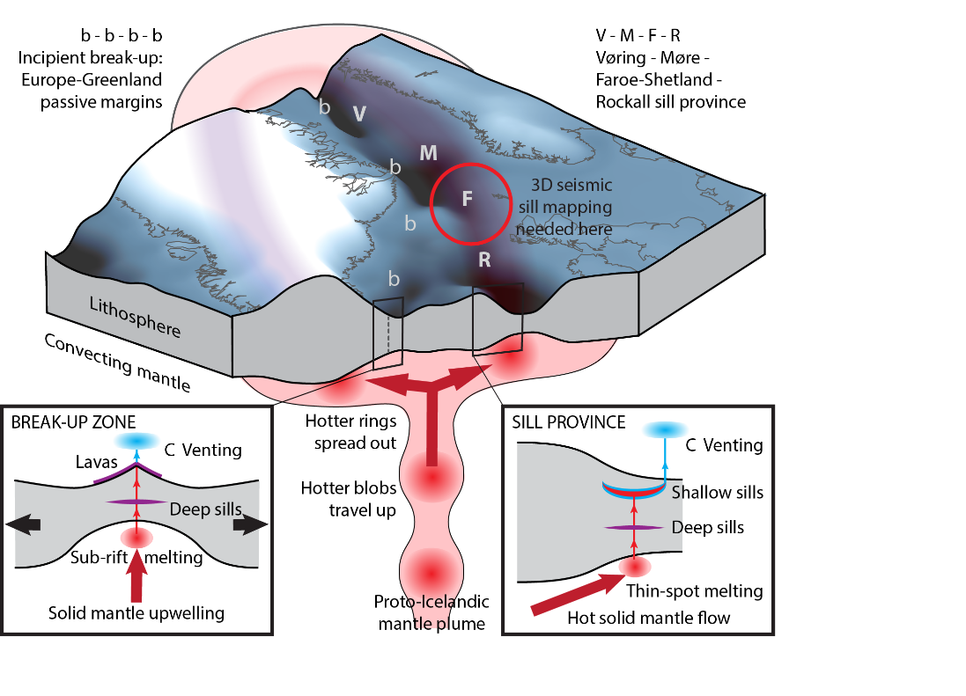
Figure 1. Framework for determining greenhouse gas emissions from the NAIP from coupled models of magma generation and emplacement after Jones et al. (2019). C-FORCE will add the purple components (deep sills, lava) to the pilot study.

Figure 2. Preliminary NAIP ‘forcing’ function (Jones et al., 2019) and PETM ‘response’ function (Gutjahr et al., 2017). The ‘residual’ (‘response’ – ‘forcing’), shows the net global C feedback flux. The REP project will contribute directly to improving the forcing function.

:

