Research Experience Placement (REP) Scheme 2023
Supervisor Project Proforma
Project title: | Unlocking the herbarium treasure-chest using Darwin’s ‘beloved Drosera’.
Host Institution: | Loughborough University
Project supervisor (name, department): | Dr Jon Millett, Geography & Environment
Project enquiries (supervisor email): | j.millett@lboro.ac.uk
Co-Supervisor, if any (name, department): | Dr Paul Roach
Proposed start date: | 19th June 2023 (flexible)
Project description (max 700 words, 1-2 figures may be included):
Proposed projects must:
- have a clearly defined objective.
- be within the science remit of NERC.
- be feasible for a student to complete within the timescale of the award.
- include more than purely a computer/modelling component i.e., some element of fieldwork, data collection, activity to give an understanding of the wider context etc.*
- give scope for thought and initiative on the part of the student and should not use the student as a general assistant.
- be based at an eligible UK research organisation (remote placements are also an option for enabling inclusivity).
Herbarium specimens—archived, dried plant specimens collected over the past 500 years—contain a wealth of information on plant biology. This treasure-chest of information provides huge potential for understanding plant responses to environmental changes such as climate change and atmospheric nitrogen deposition. Measurements of plant morphology, phenology, genetics, tissue chemistry, and herbivory, for example, allow variability in plant biology across space and time to be tracked and correlated with variability in the environment. Herbarium specimens are under-used, but this situation is changing: digitisation of herbarium records is revolutionising the use of herbarium specimens, enabling a step-change in how we can understand biological responses to environmental change.

A significant barrier to using herbarium specimens is that the ability to undertake destructive sampling is limited because of the need to preserve specimens for future users. There is, therefore, a real need for maximising the amount of information that can be gained using non-destructive approaches. This objective of this project is to investigate non-destructive measurement of herbarium specimens, using the carnivorous plant Drosera rotundifolia.
Drosera rotundifolia (roundleaved sundew) is a common carnivorous plant with a wide boreal distribution. This species grows in bog habitats, and supplements root nutrient uptake by catching prey on sticky traps (modified leaves). This is a sentinel species because it is extremely sensitive to environmental variability. Drosera rotundifolia varies at morphological, chemical and molecular scales in response to small changes in root nutrient availability or shade. Traps become less sticky in nutrient replete and shaded environments; consequently, plants catch less prey. Measuring appropriate chemical and morphological characteristic can, therefore, give insight into the biological impact of environmental change on this species, and on bog habitats in general.
This project will use Drosera herbarium specimens collected by Dr Jonathan Millett. These have been collected for the purpose of comparing non-destructive measurements with destructive measurements. There is flexibility in the choice of approaches but the project might use Fourier Transformed Infrared Spectroscopy (FTIR), portable X-Ray fluorescence (pXRF), electron microscopy or other approaches to obtain data on specimen chemistry. They may then use standard destructive chemical approaches to measure the same data to verify the suitability of the approach. In addition, collection of new herbarium specimens may be undertaken, to determine how these properties might degrade over time after collection.
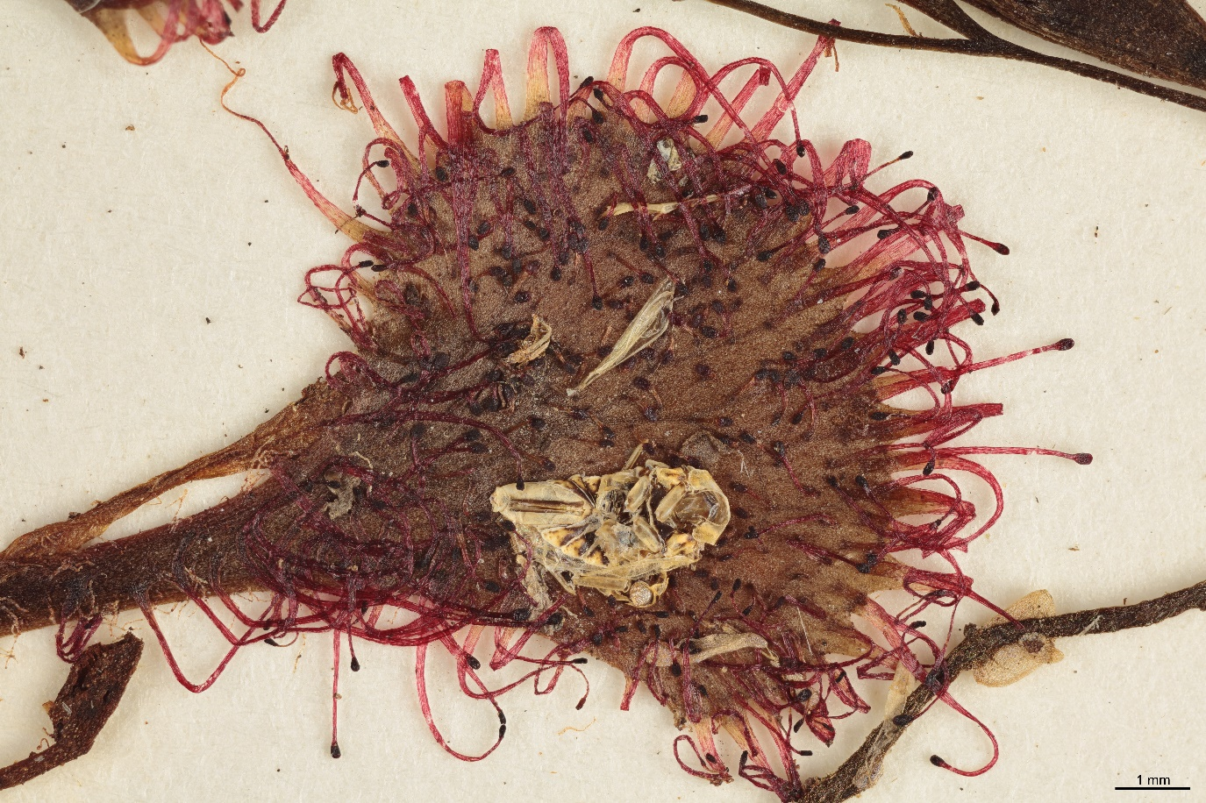
Figure 1. Drosera rotundifolia herbarium specimen collected in 1921 in Southern Sweeden. Photo credit: Patrik Frödén, Lund University.

Figure 2. Living Drosera rotundifolia growing in Southern Sweden. Photo credit: Jon Millett.
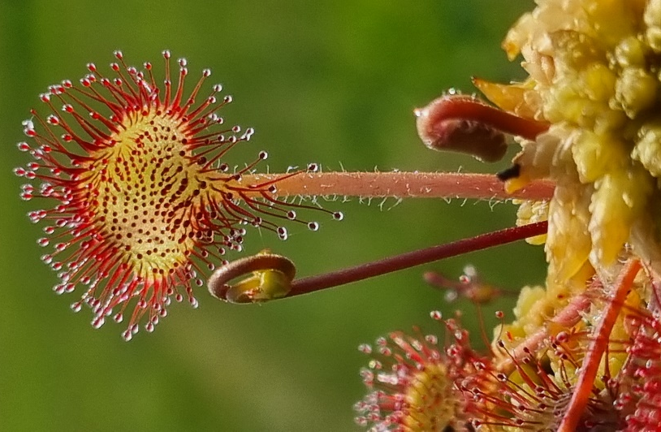

Project timeline:
Week 1: Collect Drosera rotundifolia specimens from the wild. Prepare new herbarium specimens.
Week 2: Undertake non-destructive measurements of herbarium specimens.
Week 3: Undertake non-destructive measurements of herbarium specimens.
Week 4: Undertake destructive chemical analysis of herbarium specimens.
Week 5: Undertake destructive chemical analysis of herbarium specimens.
Week 6: Data analysis and write up.

Candidate requirements:
- Undertaking an undergraduate degree in Biology or related discipline.
- Evidence of excellence in academic work to-date
- Experience of plant science lab work.
- Willingness and availability to undertake fieldwork

Background reading and references:
- Barnes, M., Sulé-Suso, J., Millett, J. and Roach, P., 2023. Fourier transform infrared spectroscopy as a non-destructive method for analysing herbarium specimens. Biology Letters, 19(3), p.20220546.
- Millett, J., Svensson, B.M., Newton, J. and Rydin, H., 2012. Reliance on prey‐derived nitrogen by the carnivorous plant Drosera rotundifolia decreases with increasing nitrogen deposition. New Phytologist, 195(1), pp.182-188.
- Lang, P.L., Willems, F.M., Scheepens, J.F., Burbano, H.A. and Bossdorf, O., 2019. Using herbaria to study global environmental change. New Phytologist, 221(1), pp.110-122.

To be completed by institutional CENTA PoC
I confirm that:
- Appropriate supervisory arrangements are in place
- Any necessary ethical committee approvals, animal licences & requirements of regulatory authorities will be in place before the work begins and will be maintained for the duration of the project
- We will take responsibility for identification, protection & exploitation of any intellectual property rights arising from the project
- All facilities, agreements regarding access and collaborations necessary for the work will be obtained before the work commences and can be ensured for the duration of the project
- All costs awarded by NERC for the REP will be used and accounted for appropriately
- A report of the project by the student will be submitted no later than one week after the end date of the placement or 15th September 2023, whichever falls first.
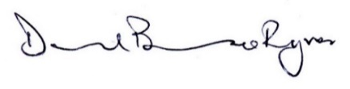
Signed:
Date: May 15th 2023
Position: Professor of Environmental Change & Centa PoC for Loughborough University

