Research Experience Placement (REP) Scheme 2023
Supervisor Project Proforma
Project title: | Evaluating the success of reed beds in reducing nutrient loading from treated sewage effluent at Rutland Water Nature Reserve.
Host Institution: | Loughborough University
Project supervisor (name, department): | Savannah Worne, Geography and Environment
Project enquiries (supervisor email): | s.worne@lboro.ac.uk
Co-Supervisor, if any (name, department): | Helen Glanville, Geography and Environment
Proposed start date: | 19/06/23
Project description (max 700 words, 1-2 figures may be included):
Proposed projects must:
- have a clearly defined objective.
- be within the science remit of NERC.
- be feasible for a student to complete within the timescale of the award.
- include more than purely a computer/modelling component i.e., some element of fieldwork, data collection, activity to give an understanding of the wider context etc.*
- give scope for thought and initiative on the part of the student and should not use the student as a general assistant.
- be based at an eligible UK research organisation (remote placements are also an option for enabling inclusivity).
The sustainability of water resources and natural habitats is threatened by algal blooms (ABs), which cause issues with the filtration, treatment and quality of drinking waters. ABs also significantly decrease the quality of aquatic habitats by altering the function, structure and unique biodiversity of these aquatic ecosystems. This is particularly relevant for standing waters which have slower flushing rates, and so accumulate pollutants. Sewage effluent is one major driver of increasing ABs in standing waters, due to phosphate and nitrate loading. While sewage entering “sensitive areas” in the UK typically undergoes tertiary treatment (nutrient removal and/or disinfection), there is uncertainty about the efficacy of these treatments as well as the impact on wider ecosystem health. Combined with future climate change, eutrophication is expected to intensify AB-related issues. There is an urgent need to better understand the impacts of sewage on ABs in standing waters and eutrophic-sensitive areas, such as Rutland Water (RW; Fig. 1).

RW is one of the UK’s largest drinking water reservoirs, providing an essential regional water supply and supporting the adjacent Rutland Water Nature Reserve (RWNR) which is composed of 8 connected lagoons. RW hosts >25,000 birds annually, including 10 internationally protected species, granting it multiple designations as an internationally protected site. However, Oakham sewage treatment works (STW) has an effluent discharge point that feeds directly into one of the lagoons (Lagoon 3; Fig 1), which in turn has a managed pipe-connection to the main reservoir. Natural England (NE) Site Improvement Plan has identified this STW as a key source of pollution, more recently highlighted by Environment Agency sampling of the final effluent where measured total phosphate (TP) levels were above the acceptable threshold for 5 of 12 surveys throughout 2022¹. Pilot ecological data from August 2022 identified significantly higher abundance of harmful cyanobacteria species in Lagoon 3, compared to Lagoon 7 which is unimpacted by STW-eutrophication. As lagoons become enriched with nutrients, they shift from clear waters dominated by submerged macrophytes to turbid waters dominated by ABs, which reduces food and habitat availability for key bird species². It is therefore critical to evaluate that the scale and nature of impact that sewage effluent is having at RW, to protect the habitat and secure its sustainability and protection.

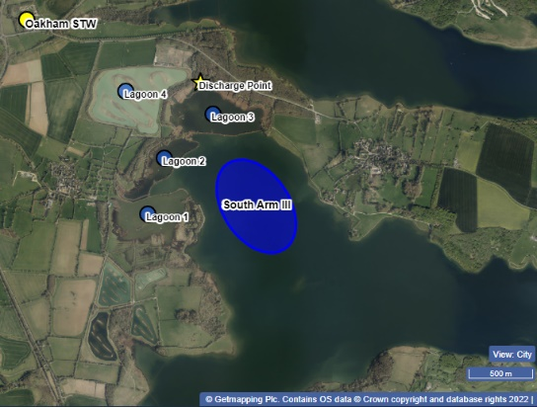
Figure 1) Map of central sector of Rutland Water Nature Reserve.

Currently, treated sewage effluent flows from the discharge point, through an extensive reed bed, before entering Lagoon 3. Reed beds are commonly used in water quality management, where they are designed to naturally filter out nutrients and increase sedimentation, to ultimately reduce eutrophication impacts downstream³. However, due to the presence of a boardwalk at the Oakham STW discharge point (to facilitate public access), the efficiency of this reed bed in questionable, as water can flow freely underneath the boardwalk. This project will evaluate how successfully the reed beds are stripping nutrients from the effluent, before entering Lagoon 3. This will be achieved through the following aims and objective:

- Fortnightly in-situ measurement of water quality (temperature, dissolved oxygen (DO), turbidity, pH and conductivity), of the sewage effluent stream, along a transect as it flows through the boardwalk.
- Fortnightly collection of water samples along a transect of the sewage effluent stream, analysed for total suspended solids, total phosphates, soluble reactive phosphates (SRP), ammonium (NH₄), anions (chloride, nitrate and sulphate), cations (Sodium, Potassium, Calcium and Magnesium), total alkalinity, chlorophyll-a concentrations and biological oxygen demand.
- Monthly collection of surface sediment samples along a transect of the sewage effluent stream, analysed for total nitrogen, total carbon and phosphate speciation.

The research undertaken by the student in this project will contribute to a wider body of research at RWNR undertaken by the Dr. Worne, which is evaluating the spatial variability in water quality across the whole site. Data from this study will be used to provide evidence to the Leicestershire and Rutland Wildlife Trust, and Anglian Water, who co-manage the site, about the efficacy of the reed beds, and be used to inform further study around water quality management practices.

Project timeline:
Week 1:
- Health and Safety briefing, lab induction, familiarisation with lab methods and reading around project.

Weeks 2, 4 and 6:
- Fortnightly field work will take place to collect water samples and take in-situ water quality measurements.
- Subsequent laboratory analysis of waters.

Weeks 2 and 4:
- On two of the four field surveys surface sediment samples will also be collected.
- Subsequent laboratory analysis of sediments.

Weeks 3 and 5:
- Time in-between survey and analysis weeks will be used to type up and analyse data, including undertaking GIS analysis of results.

Week 7:
- Outputs of the student project should be a short data report, including a GIS map that demonstrates any spatial findings.

Candidate requirements:
Essential:
- Interest in working in both field and laboratory environments.
- Be willing to undertake repetitive tasks.
- Ability to work in Loughborough for the duration of the project.
- Ability to work out of core work hours (due to time-sensitive nature of laboratory analysis).
- Interest in aquatic environmental science/water management.

Desirable:
- Experience working in a laboratory environment.
- Experience with use of GIS.

Background reading and references:
References:
1. Environment Agency (2023). Environment Agency Water Quality Archive: Oakham STE Final Effluent.
2. Pringle, H. E. K. & Burton, N. H. K. (2017). Improving understanding of the possible relationships between improving freshwater and coastal water quality and bird interest on designated sites - phase 1 review.
3. Haberl, R & Perfler, R. (1990). Seven years of research work and experience with wastewater treatment by a reed bed system. Proceedings of the International Conference on the Use of Constructed Wetlands in Water Pollution Control, Held in Cambridge, UK, 24–28 September 1990, pp. 205-214.

To be completed by institutional CENTA PoC
I confirm that:
- Appropriate supervisory arrangements are in place
- Any necessary ethical committee approvals, animal licences & requirements of regulatory authorities will be in place before the work begins and will be maintained for the duration of the project
- We will take responsibility for identification, protection & exploitation of any intellectual property rights arising from the project
- All facilities, agreements regarding access and collaborations necessary for the work will be obtained before the work commences and can be ensured for the duration of the project
- All costs awarded by NERC for the REP will be used and accounted for appropriately
- A report of the project by the student will be submitted no later than one week after the end date of the placement or 15th September 2023, whichever falls first.
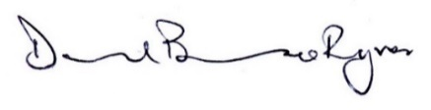
Signed:
Date: May 15th 2023
Position: Professor of Environmental Change & Centa PoC for Loughborough University

