Research Experience Placement (REP) Scheme 2023
Supervisor Project Proforma
Project title: | 2D and 3-D imaging of melt-bombs formed during asteroid impacts and volcanic eruptions
Host Institution: | University of Leicester
Project supervisor (name, department): | Tiffany Barry
Project enquiries (supervisor email): | tlb2@le.ac.uk
Co-Supervisor, if any (name, department): | Mike Branney
Proposed start date: | June, 2023
Project description (max 700 words, 1-2 figures may be included):
Proposed projects must:
- have a clearly defined objective.
- be within the science remit of NERC.
- be feasible for a student to complete within the timescale of the award.
- include more than purely a computer/modelling component i.e., some element of fieldwork, data collection, activity to give an understanding of the wider context etc.*
- give scope for thought and initiative on the part of the student and should not use the student as a general assistant.
- be based at an eligible UK research organisation (remote placements are also an option for enabling inclusivity).
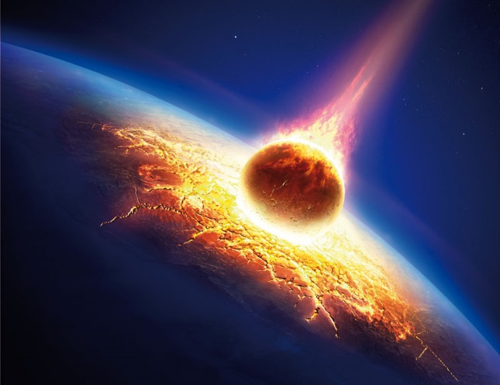
Image shows an artist’s impression of an asteroid hitting the surface of a planet.

Background to the project:
When asteroids collide with rocky planets like Earth, an impact-crater is formed by the ejection of shocked and melted rock. As part of a wider investigation of the mechanisms of ejecta formation, this internship will consider the 3D shape of melt bombs ejected from the impact, and compare them with bombs generated at volcanic eruptions. Fluidal clots of liquid rock (known variously as ‘flädler ‘and ‘spatter rags’) fly through the air and form hot accumulations that eventually cool to form rocky deposits of ejecta. Such bombs may have ellipsoidal, amoeboid, or folded pancake shapes, and they may stretch or fold as they fly though the air and land upon the ground. Geologists study the outline shapes of former bombs within deposits, and use their shapes to work out how, and under what conditions the melt fragmented and travelled from the crater. To do this, the 3D shape (morphology) of former melt bombs is inferred from 2D cross-sections, as viewed from cut rock surfaces.

Objective:
This internship will use Blender and Python to explore the relationship between the 3D shape of melt clots as they fly through the air, with their 2D shape as viewed in natural deposits of impact-ejecta. Using Blender the student will draw idealised ‘end-member’ shapes of melt bombs, based on samples collected from volcanoes and asteroid-impact deposits. Then, a geological site at Santorini volcano, Greece, will be visited (7 days) together with a PhD student, to characterise and record the complex 3D shapes of bombs there. By photography and scanning, the morphology of natural spatter bombs on Santorini will be photographed, and 3D digital models recreated in Blender. The student will then code Python to produce multiple 2D cross-sections (i.e. serial slicing) at all possible orientations through the main contrasting types of melt bombs, and present their findings as a series of tables of multiple possible 2D outlines that correspond to each different 3D bomb shape. Results of the project will be a useful step to help geologists deduce the likely 3D morphology of former melt bombs from 2D outlines as revealed in flat surfaces cut through natural ejecta deposits.
The work will contribute to a NERC-funded project entitled : ‘A fresh look at asteroid impact cratering: how do melt-bearing impact deposits form’ (Prof M. Branney and Dr T. Barry, SGGE, University of Leicester). The internship will suit a student with coding experience (Python) and imaging using Blender. The student will benefit from practical supervision by team members Branney, Barry, Clarke and Bowden-Haynes, and gain imaging and fieldwork experience at a Greek volcano.

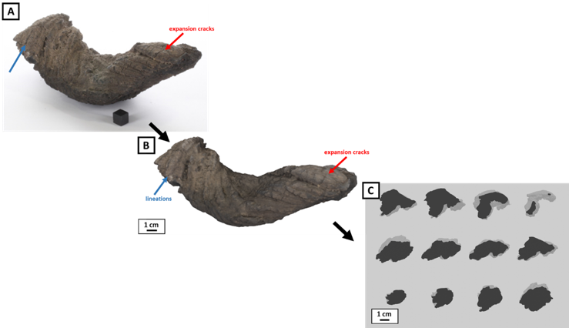

Figure shows a twisted volcanic bomb with inset (c) displaying some of the cross-sectional slices through the bomb.

Project timeline:
Project can begin as early in the summer as suits the applicant, with field work arranged to suit the successful applicant and PGR Bowden-Haynes.

Candidate requirements:
A background in computer science or creative media, with a high level of competency in coding and use of Blender (or similar software).

Must be enrolled on an undergraduate degree at the time of starting the internship.

Background reading and references:

To be completed by institutional CENTA PoC
I confirm that:
- Appropriate supervisory arrangements are in place
- Any necessary ethical committee approvals, animals licences & requirements of regulatory authorities will be in place before the work begins and will be maintained for the duration of the project
- We will take responsibility for identification, protection & exploitation of any intellectual property rights arising from the project
- All facilities, agreements regarding access and collaborations necessary for the work will be obtained before the work commences and can be ensured for the duration of the project
- All costs awarded by NERC for the REP will be used and accounted for appropriately
- A report of the project by the student will be submitted no later than one week after the end date of the placement or 15th September 2023, whichever falls first.

Signed: Tiffany Barry
Date: 2nd May 2023
Position: Associate Professor

