Research Experience Placement (REP) Scheme 2024
Supervisor Project Proforma
Project title: | Biodiversity consequences of wildfire mitigation strategies
Host Institution: | University of Birmingham
Project supervisor (name, department): | Nick Kettridge – Geography, Earth and Environmental Sciences
Project enquiries (supervisor email): | n.kettridge@bham.ac.uk
Co-Supervisor, if any (name, department): | Laura Graham
Proposed start date: | l.graham@bham.ac.uk
Project description (max 700 words, 1-2 figures may be included):
Proposed projects must:
- have a clearly defined objective
- be within the science remit of NERC
- be feasible for a student to complete within the timescale of the placement
- include more than purely a computer/modelling component i.e., some element of fieldwork, data collection, activity to give an understanding of the wider context including participation in lab/team meetings, networking and training etc.
- give scope for thought and initiative on the part of the student and should not use the student as a general assistant
- be based at an eligible UK research organisation (remote placements are also an option for enabling inclusivity).

Targeted management of the UK's fire prone landscapes will be crucial in enabling the country to achieve its commitments both to reach net zero by 2050 and to halt species decline by 2030. Many of our fire prone landscapes represent nationally significant carbon stores. They also provide key habitats for unique species including many of strategic conservation value. But these typically shrub and grass dominated ecosystems are threatened both by the changing UK wildfire regime and some management tools aimed to mitigate this risk. Critical trade-offs therefore exist between the impact of episodic severe wildfire events and ongoing long term management practises, as well as between the positive and negative impacts of management tools on carbon storage, habitat management and biodiversity provision.

To support enhanced landscape management, we are determining the environmental costs and benefits of widely applied fuel management tools (burning, cutting, rewetting and managed succession) on habitat quality and biodiversity in fire prone UK landscapes. Medium and long-term impacts of fuel management interventions are being contrasted to the impact and potential wildfires of varying severity. The results from this research will be embedded into newly developed accredited training modules for the land management sector, supporting them to make informed decisions in their landscapes to best meet both national and local management goals.

Supporting this overall projected, the advertise research aims to determine the impact of burning, cutting, rewetting and managed succession on insect biomass (although depending on the interests of the appointed candidate other aims can be considered related to vegetation or bats for example). Working in collaboration with a research technician at the University of Birmingham, the candidate will determine above-ground invertebrate biomass using a combination of standardised sweep-net and vacuum sampling of multiple quadrats (the two approaches tend to favour different groups and sizes of invertebrates) along a fuel management chronosquences (5, 10 and up to 20 years post intervention) within the Scottish Boarders, the Peak district, the New Forest and the North York Moors. As such, this is a field-based project, with much of the time spent away from Birmingham collecting data across the different sites. Therefore, the successful candidate should be willing to be away from Birmingham for extensive periods during this project. Field based data collection will be supplemented with laboratory-based sample analysis, data analysis and interpretation at the university, working in collaboration with the biodiversity research team, including ongoing CENTA research into the vegetation management approaches to manage heathland biodiversity.

The project will enhance the employability of the studentship holder. It will embed them directly within the activities of a large-scale funded research programme across multiple institutions and develop extensive field-based experience and skills. This will help develop a clear route for the individual into the environment sector, notably into areas of environmental consultancy, government organisations including Natural England, the Environment Agency, or the land management sector. The experience of intensive field-based and applied working practises will also support them in their consideration of their future career direction. The studentship will provide a strong contrast from the computer and office-based activities that likely provide a significant foundation to their university activities to date.

Project timeline:
This project will be carried out for a period of 6 weeks in the summer, sometime between June- October 2024 (the exact timings and dates to be confirmed in collaboration with the successful candidate).

Candidate requirements:
The post holder should have a willingness and enthusiasm to undertake extensive field work within remote regions of the UK and demonstrate the independence, initiative and problem-solving skills required for this to be undertaken safely and successfully. No prior ecological or technical skills are required to undertake the activities during the studentship, these will all be taught to the individual through the course of the project.

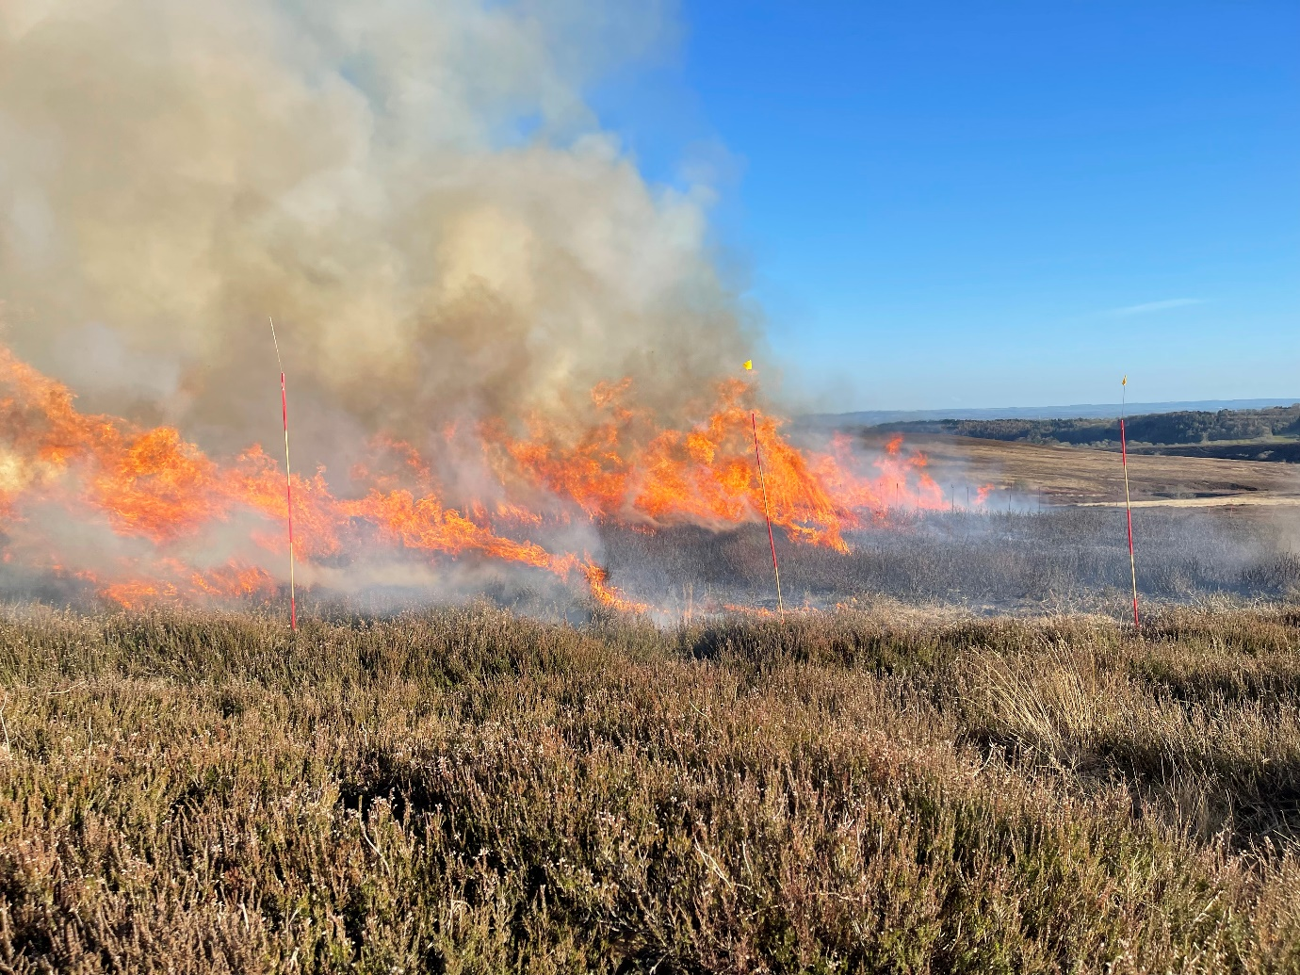

Background reading and references:
Belcher, C., Brown, I., Clay, G., Doerr, S., Elliott, A., Gazzard, R., Kettridge, N., Morison, J., Perry, M., Santin, C. and Smith, T., 2021. UK wildfires and their climate challenges: Expert Led Report Prepared for the third Climate Change Risk Assessment.

Tasker S and Wentworth J 2024 Wildfire risks to UK landscapes, UK Parliament POSTnote 717 https://doi.org/10.58248/PN717

Glaves, DJ, Morecroft, M, Fitzgibbon, C, Lepitt, P, Owen, M and Phillips, S. 2013.
Natural England Review of Upland Evidence 2012 - The effects of managed burning on upland
peatland biodiversity, carbon and water. Natural England Evidence Review, Number 004.

To be completed by institutional CENTA PoC
I confirm that:
- The host institution takes responsibility for selecting a suitable undergraduate student and ensuring eligibility (see NERC REP student eligibility requirements above) and confirming their eligibility using the UKRI criteria listed under the NERC REP student eligibility criteria
- This REP project falls within the NERC remit and is of suitable quality
- Appropriate supervisory arrangements are in place
- The student recruited to undertake this placement will have a PhD student mentor from the DTP/CDT
- The application processes used will be inclusive and accessible
- Reasonable adjustments will be made for students that need them whilst undertaking placements
- The placement will be carried out in accordance with all applicable ethical, legal and regulatory requirements including but not limited to relevant provisions of the General Data Protection Regulation, the Data Protection Act 2018, the Bribery Act 2010, the Fraud Act 2006, the Equality Act 2010 and the Modern Slavery Act 2015
- The host organisation takes responsibility for identification, protection and exploitation of any intellectual property rights arising from the work
- All facilities, agreements about access and collaborations necessary for the work will be obtained before the work commences and can be ensured through the period of the work
- All costs awarded by NERC for the REPs will be used and accounted for appropriately
- A report of the project by the student will be submitted no later than one week after the end date of the placement or Friday 27th September 2024, whichever falls first.

Signed: Tom Matthews
Date: 25/04/2024
Position: Birmingham PoC

