Research Experience Placement (REP) Scheme 2024
Supervisor Project Proforma
Project title: | The construction of deep time: an interdisciplinary investigation
Host Institution: | University of Birmingham
Project supervisor (name, department): | Sarah Greene
Project enquiries (supervisor email): | s.e.greene@bham.ac.uk
Co-Supervisor, if any (name, department): | Emma Dunne, Nussaïbah Raja, FAU Erlangen (Germany)
Proposed start date: | July 1, 2024
Project description (max 700 words, 1-2 figures may be included):

The geological timescale is a critical tool for unravelling the history of our planet. Every fossil, sedimentary rock, or outcrop has a story to tell, but without temporal context — knowing when in geologic time it lived or was deposited — it is impossible for geologists to fully interpret that history and its significance (Fig. 1). To assign absolute ages (e.g., ‘150 million years ago’) or relative ages (e.g., ‘upper Jurassic’) to sedimentary successions or fossils requires a communally-agreed system of keeping geologic time.

The development of the geologic time scale is a multidecadal, and still ongoing, international community effort. The body responsible for the construction of this timescale is the International Commission on Stratigraphy (ICS), whose primary objective is to define the International Geological Timescale “thus setting global standards for the fundamental scale for expressing the history of the Earth.” An important component of this work is ratifying a Global Stratotype Section and Point (GSSP) to define the lower boundary of each geological stage. Thus, one location on one outcrop in one place on the planet becomes the temporal reference point for all rocks of similar age.

There are numerous rules governing the choice of a GSSP, including stratigraphic properties and accessibility considerations. Nonetheless, despite a more or less global distribution of sedimentary rock packages which might yield suitable GSSP candidates, when one looks at the locations of ratified GSSPs, a pattern begins to emerge: they are clustered in the global North (Fig. 2). How did this pattern come to be? Is it the result of natural (geological, geomorphological, climatological) phenomena or is it a historical and political?

The legacy of colonialism, in the form of asymmetrical knowledge production and power structures, is evident in many scientific fields. This is particularly true of palaeontology and geology, extractive disciplines that are rooted in colonialism, where wealthy and resource-rich countries remain centres of power and knowledge generation, often at the expense of lower income countries (Raja et al. 2022).

In this project, you will contribute to a scientometric study (e.g. Raja et al., 2022) about how GSSPs are produced. This involves collating authorship affiliation data and undertaking network analyses (e.g., in a programming language like R). You will also collect data on barriers to international travel to GSSPs for the global geological scientific community. There are several possible directions this project could go beyond this depending on the skills and background of the appointee. If you have advanced coding skills, we would like you to experiment with data visualisation. If you have foreign language skills, these may be useful for a literature review component. The project is part of the Pal(a)eoscientometrics Research Collective.

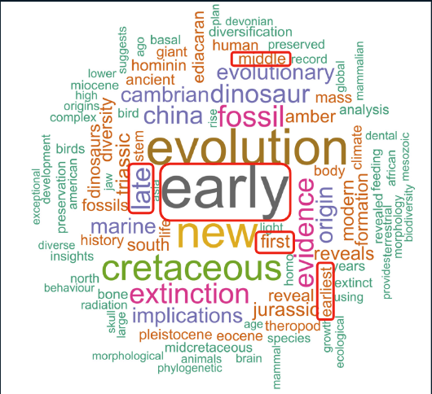
Fig. 1 after Raja and Dunne, 2022. Word cloud of the top words used in the title of palaeontological publications in the Springer Nature group and Science journals published during the period December 2015 to November 2020. The size of the word represents its frequency (i.e. the bigger the word, the more often it is used in article titles). Red rectangles highlight a handful of the most common titular words that refer to geologic time.

Fig. 2 Global distribution of GSSPs, from https://stratigraphy.org/gssps/.
Project timeline:
We expect a commitment of the equivalent of 6 weeks full time work, but the project timeline is very flexible and the specific schedule will be mutually agreed between the appointed student and the supervisory team.

Candidate requirements:
Necessary skills:
Background in geoscience
Some experience using coding to organise data and make figures (language of your choice, e.g. R, Python, MATLAB)

Desired:
Interdisciplinary background/interests aligned with the topic.

Bonus:
Fluency in any foreign language in which stratigraphic research is routinely published.

Background reading and references:
Suggested reading:
Raja, N.B., Dunne, E.M., Matiwane, A. et al., 2022. Colonial history and global economics distort our understanding of deep-time biodiversity. Nat Ecol Evol 6, 145–154. https://doi.org/10.1038/s41559-021-01608-8
Lucas, S.G., 2018. The GSSP Method of Chronostratigraphy: A Critical Review. Front. Earth Sci. 6:191. https://doi.org/10.3389/feart.2018.00191
Chugh, M. and Joseph, T., 2024. Citizenship privilege harms science. Nature 628, 499-501. https://doi.org/10.1038/d41586-024-01080-x

Full references:
Raja N.B., and Dunne, E.M., 2022. Publication pressure threatens the integrity of palaeontological research. The Geological Curator 11:7, 407-418. https://doi.org/10.55468/GC1459

To be completed by institutional CENTA PoC
I confirm that:
- The host institution takes responsibility for selecting a suitable undergraduate student and ensuring eligibility (see NERC REP student eligibility requirements above) and confirming their eligibility using the UKRI criteria listed under the NERC REP student eligibility criteria
- This REP project falls within the NERC remit and is of suitable quality
- Appropriate supervisory arrangements are in place
- The student recruited to undertake this placement will have a PhD student mentor from the DTP/CDT
- The application processes used will be inclusive and accessible
- Reasonable adjustments will be made for students that need them whilst undertaking placements
- The placement will be carried out in accordance with all applicable ethical, legal and regulatory requirements including but not limited to relevant provisions of the General Data Protection Regulation, the Data Protection Act 2018, the Bribery Act 2010, the Fraud Act 2006, the Equality Act 2010 and the Modern Slavery Act 2015
- The host organisation takes responsibility for identification, protection and exploitation of any intellectual property rights arising from the work
- All facilities, agreements about access and collaborations necessary for the work will be obtained before the work commences and can be ensured through the period of the work
- All costs awarded by NERC for the REPs will be used and accounted for appropriately
- A report of the project by the student will be submitted no later than one week after the end date of the placement or Friday 27th September 2024, whichever falls first.

Signed: Tom Matthews
Date: 25/04/2024
Position: Birmingham PoC

