Research Experience Placement (REP) Scheme 2024
Supervisor Project Proforma
Project title: | Pollution-induced epigenetic changes in environmentally important invertebrates.
Host Institution: | University of Leicester
Project supervisor (name, department): | Dr Hollie Marshall, Department of Genetics and Genome Biology
Project enquiries (supervisor email): | Hjm32@leicester.ac.uk
Co-Supervisor, if any (name, department): | Prof Eamonn Mallon, Department of Genetics and Genome Biology
Proposed start date: | Negotiable (suggestion: June 17th)
Project description (max 700 words, 1-2 figures may be included):

It has only recently become apparent that ancestral pollutant exposure can cause negative population health outcomes in future generations no longer exposed, and that these populations show a lower ability to cope with novel environmental stress. This has serious implications for species conservation efforts, as removal of environmental pollution alone, may not be enough to rescue declining populations. In order to develop tools for predicting future population health outcomes, we need to understand how environmental information can be passed from one generation to the next.

Epigenetic mechanisms, such as DNA methylation, provide a means of transmitting information about the environment to new generations. DNA methylation is the addition of a methyl-group to a cytosine nucleotide. In many species this epigenetic mark directly regulates gene expression. However, more recently, it has become apparent that it can also play a role of mediating transgenerational health and may be involved in how species adapt to novel environmental stress.

To examine the role of DNA methylation in the transgenerational response to pollutant exposure, we must first understand how DNA methylation initially changes within an exposed individual. The aim of this project is to examine pollutant-induced DNA methylation changes in key genes within a model epigenetic invertebrate species.

Specifically, this project will examine the phenotypic effects (mortality, fecundity, growth) of pollutant exposure and identify any pollutant-induced DNA methylation changes in key genes via bisulfite-PCR. You will have a choice of species/pollutant based on your personal interests.
Species available (Fig.1):
Nasonia vitripennis (terrestrial insect)
Daphnia magna (freshwater crustacean)
Parhyale hawaiensis (marine amphipod)
Pollutants available:
Glyphosate (agricultural herbicide)
Polypropylene (microplastic)
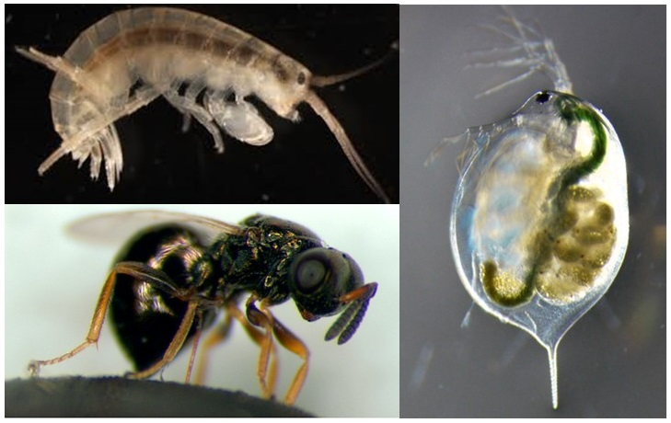
4-nonylphenol (endocrine disruptor from sewage)

Figure 1: top left: Parhyale hawaiensis, bottom left: Nasonia vitripennis, right: Daphnia magna.
Project timeline:
Week 1: Setting up your own invertebrate stock, trialling a DNA extraction, getting used to the lab
Week 2: Setting up an exposure experiment, beginning phenotypic data collection, designing primers
Week 3: Phenotypic data collection, trialling bisulfite treatment of DNA, trialling primers
Week 4: Phenotypic data collection, extracting DNA from your experiment
Week 5: Bisulfite treatment of your DNA and PCR
Week 6: Analysing your final phenotypic and PCR data

Candidate requirements:
At least one module with some genetics which included at least one wet-lab practical, i.e. they have heard of the PCR technique and know how to use a pipette.

Background reading and references:
Abdullahi, et al. (2022). Historical exposure to chemicals reduces tolerance to novel chemical stress in Daphnia (waterflea). Molecular Ecology. 31(11), p3098-3111.

dos Santos et al. (2022) The amphipod Parhyale hawaiensis as a promising model in ecotoxicology. Chemosphere. 307: 135959.

Harney, et al. (2022). Pollution induces epigenetic effects that are stably transmitted across multiple generations. Evolution Letters. 6 (2), p118-135.

Wang, et al. (2013). Function and evolution of DNA methylation in Nasonia vitripennis. PLoS Genetics. 9(10), e100872.

Beginners guide to bisulfite-PCR: Bisulfite_Beginner_Guide.pdf (bioscience.co.uk)

To be completed by institutional CENTA PoC
I confirm that:
- The host institution takes responsibility for selecting a suitable undergraduate student and ensuring eligibility (see NERC REP student eligibility requirements above) and confirming their eligibility using the UKRI criteria listed under the NERC REP student eligibility criteria
- This REP project falls within the NERC remit and is of suitable quality
- Appropriate supervisory arrangements are in place
- The student recruited to undertake this placement will have a PhD student mentor from the DTP/CDT
- The application processes used will be inclusive and accessible
- Reasonable adjustments will be made for students that need them whilst undertaking placements
- The placement will be carried out in accordance with all applicable ethical, legal and regulatory requirements including but not limited to relevant provisions of the General Data Protection Regulation, the Data Protection Act 2018, the Bribery Act 2010, the Fraud Act 2006, the Equality Act 2010 and the Modern Slavery Act 2015
- The host organisation takes responsibility for identification, protection and exploitation of any intellectual property rights arising from the work
- All facilities, agreements about access and collaborations necessary for the work will be obtained before the work commences and can be ensured through the period of the work
- All costs awarded by NERC for the REPs will be used and accounted for appropriately
- A report of the project by the student will be submitted no later than one week after the end date of the placement or Friday 27th September 2024, whichever falls first.

Signed: THPHarvey
Date: 19th April 2024
Position: Deputy point of contact for CENTA, University of Leicester

