Research Experience Placement (REP) Scheme 2024
Supervisor Project Proforma
Project title: | The ecological recovery of macroinvertebrate communities in agricultural sediment ponds to sedimentation events and desilting activities
Host Institution: | Loughborough University
Project supervisor (name, department): | Kate Mathers and Paul Wood, Geography
Project enquiries (supervisor email): | K.mathers@lboro.ac.uk and p.j.wood@lboro.ac.uk
Co-Supervisor, if any (name, department):
Proposed start date: | 1st July 2024
Project description (max 700 words, 1-2 figures may be included):
Proposed projects must:

Project Introduction / Aims

Agriculture covers 70% of the land surface in England (DEFRA, 2023), which can have an adverse impact on water quality and ecology. Agricultural interventions, such as sediment ponds developed through agri-environmental schemes can reduce the impact of agricultural practices on water quality by trapping run-off from fields allowing it to settle out. Currently, there is no agreed definition of a ‘sediment pond ‘and therefore the following definition is being employed in this study:
“A sediment pond is an artificially, shallow basins that captures excess water-borne soil and nutrients that would otherwise be transported and subsequently deposited into riverine ecosystems and thereby impairing ecosystem health.”

As well as effective water and sediment storage, sediment ponds may provide a unique habitat for a wide range of flora and fauna, particularly aquatic macroinvertebrates (Williams et al., 2004). However, sediment ponds are susceptible to extreme sediment loading which may lead to adverse impacts on aquatic macroinvertebrate communities (Hill et al., 2021). Additionally, the management activities taken after a pond is filled entirely with sediment will have implications for aquatic biodiversity and therefore, tracking the recovery of macroinvertebrate communities is important to understand the conservation value of sediment ponds and how they function in the agricultural landscape (Sayer et al., 2012). The aim of the project is to use macroinvertebrate, physiochemical, and environmental data from three ponds in Herefordshire (Figure 1), to observe the: 1) ecological impact of varying levels of sediment loading on macroinvertebrate communities and the; 2) ecological recovery of macroinvertebrate communities following the desilting of one sediment pond (undertaken in Spring 2024).

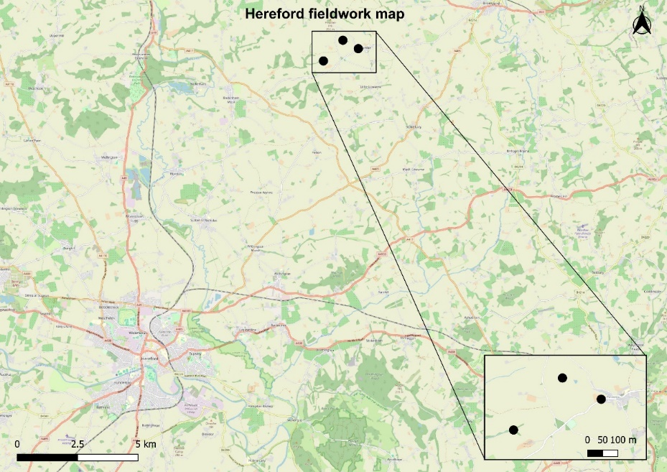

Figure 1: Location of predetermined sampling sites of three sediment ponds to be studied in Herefordshire.

Methodology
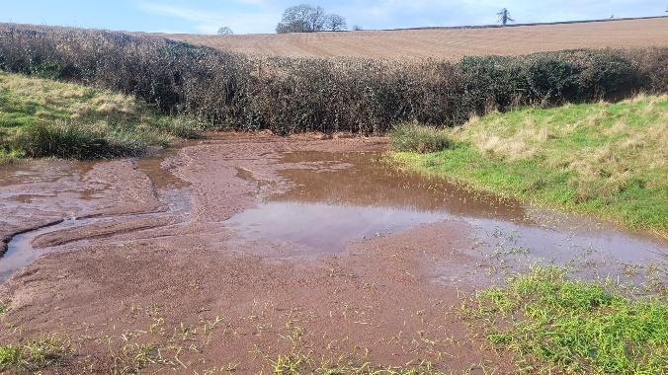
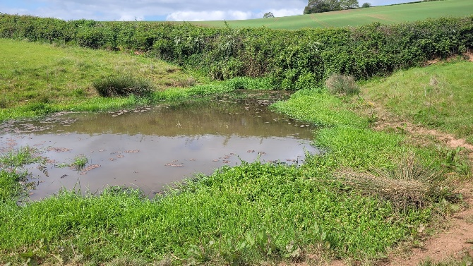
Three predetermined sediment ponds in Herefordshire have been selected which receive varying levels of sediment loading from agricultural land during high rainfall / runoff events. These span a gradient from negligible sediment input, moderately impacted, and highly impacted (Figure 2). A standard 3-minute sweep sample, as outlined by the Freshwater Habitats Trust (Action, 2002), will be taken at each pond using a 1-mm mesh pond net to determine the macroinvertebrate communities. The 3-minute sampling time will be divided equally between each meso-habitat available within the pond as different species of macroinvertebrates occupy different habitats (Hill et al., 2016). A multi-parameter water quality probe will record physiochemical conditions alongside observational data. Pre-samples have already been taken during Autumn 2023, Winter and Spring 2024 and the project will provide further opportunities to undertake sampling during Summer 2024 following the desilting of the heavily impacted pond.
Figure 2: Before (left) and after (right) photographs of the highly impacted sediment pond following an intensive soil runoff event. This pond will undergo desilting in Spring 2024 via excavation using diggers.

After samples have been taken, they will be preserved and stored before processing. In the
laboratory, samples will be washed through a 2-mm sieve and a finer 500-µm mesh. The sample retained will be placed into white trays and macroinvertebrates manually picked and identified to species level (where possible) using a stereo microscope and specialist identification keys. The project has been designed to allow the successful candidate to actively participate in field and lab work providing a diverse range of activities throughout the duration of the project.
The fieldwork will include the summer sampling of the three sites and is intended to take place between W/C 8th or 15th July depending on availability. After the fieldwork is completed, the candidate will be required to process the macroinvertebrate samples by picking, sorting, and identifying the macroinvertebrates.

Project timeline: Six weeks
Week 1: Introduction to supervisors & project, laboratory induction, and Health & Safety details. Fieldwork in Herefordshire to be completed (2 – 3 days) and processing water samples in the laboratory.
Week 2: Begin invertebrate processing in the laboratory. This involves rinsing and washing the samples through sieves wit samples then placed in a white tray. Subsequently invertebrates are picked into vials and stored prior to subsequent identification.
Week 3: Continue invertebrate processing of picking invertebrates as in week 3. Once all picking is completed, start macroinvertebrate identification to species level using a microscope and identification keys.
Week 4: Continue macroinvertebrate identification.
Week 5: Continue macroinvertebrate identification. Once completed, type up data into Excel and undertake basic exploration and analysis of the data such as the creation of graphs to observe community differences associated with the three different sediment loads. Begin report writing on how the macroinvertebrate communities are impacted by sediment loading events and detail the ecological recovery following desilting of the heavily impacted pond.
Week 6: Continue and finish the report.

Candidate requirements:
Essential:
- Ability to work from Loughborough when required for Laboratory work
- Willingness to work outside undertaking fieldwork
- Willingness to undertake repetitive tasks
- Excellent written and oral communication skills
- Ability to work independently and as part of a team and to collaborate with others
- Excellent interpersonal, and organisational skills
- Self-motivated with ability to meet deadlines

Desired:
- Experience of working with freshwater organisms, in particular macroinvertebrates
- Experience of working in laboratories / in the field

Background reading and references:
- Williams, P., Whitfield, M., Biggs, J., Bray, S., Fox, G., Nicolet, P., & Sear, D. (2004) Comparative biodiversity of rivers, streams, ditches, and ponds in an agricultural landscape in Southern England. Biological conservation, 115(2), 329-341.

- Hill, M. J., Sayer, C. D., & Wood, P. J. (2016) When is the best time to sample aquatic macroinvertebrates in ponds for biodiversity assessment? Environmental Monitoring and Assessment, 188, 1-11.

- Hill, M. J., Greaves, H. M., Sayer, C. D., Hassall, C., Milin, M., Milner, V. S., & Wood, P. J. (2021) Pond ecology and conservation: research priorities and knowledge gaps. Ecosphere, 12(12), e03853.

- Sayer, C., Andrews, K., Shilland, E., Edmonds, N., Edmonds‐Brown, R., Patmore, I., & Axmacher, J. (2012) The role of pond management for biodiversity conservation in an agricultural landscape. Aquatic Conservation: Marine and Freshwater Ecosystems, 22(5), 626-638.

- Robotham, J., Old, G., Rameshwaran, P., Sear, D., Trill, E., Bishop, J., & McKnight, D. (2023) Nature‐based solutions enhance sediment and nutrient storage in an agricultural lowland catchment. Earth Surface Processes and Landforms, 48(2), 243-258.

- Ruggiero, A., Céréghino, R., Figuerola, J., Marty, P., & Angélibert, S. (2008) Farm ponds make a contribution to the biodiversity of aquatic insects in a French agricultural landscape. Comptes Rendus Biologies, 331(4), 298-308.

- Wood, P. J., Greenwood, M. T., & Agnew, M. D. (2003) Pond biodiversity and habitat loss in the UK. Area, 35(2), 206-216.

- Action, P. (2002) A guide to monitoring the ecological quality of ponds and canals using PSYM. Environment Agency, Pond Action, Oxford.

- https://www.gov.uk/government/statistics/agricultural-land-use-in-england/agricultural-land-use-in-england-at-1-june-2023

- https://freshwaterhabitats.org.uk/habitats/ponds/

To be completed by institutional CENTA PoC
I confirm that:
- The host institution takes responsibility for selecting a suitable undergraduate student and ensuring eligibility (see NERC REP student eligibility requirements above) and confirming their eligibility using the UKRI criteria listed under the NERC REP student eligibility criteria
- This REP project falls within the NERC remit and is of suitable quality
- Appropriate supervisory arrangements are in place
- The student recruited to undertake this placement will have a PhD student mentor from the DTP/CDT
- The application processes used will be inclusive and accessible
- Reasonable adjustments will be made for students that need them whilst undertaking placements
- The placement will be carried out in accordance with all applicable ethical, legal and regulatory requirements including but not limited to relevant provisions of the General Data Protection Regulation, the Data Protection Act 2018, the Bribery Act 2010, the Fraud Act 2006, the Equality Act 2010 and the Modern Slavery Act 2015
- The host organisation takes responsibility for identification, protection and exploitation of any intellectual property rights arising from the work
- All facilities, agreements about access and collaborations necessary for the work will be obtained before the work commences and can be ensured through the period of the work
- All costs awarded by NERC for the REPs will be used and accounted for appropriately
- A report of the project by the student will be submitted no later than one week after the end date of the placement or Friday 27th September 2024, whichever falls first.

Signed:
Date: 19th April 2024
Position: Loughborough University CENTA2 Point of Contact
Professor of Ecohydrology and Physical Geography

